Name:___________________

PAUL IN ATHENS

UNDERSTANDING IDOLATRY: GRAECO-ROMAN STATUES AND THE JEWS

I. STATUES AND SYMBOLIC MEANING

A. Do you recognize this modern statue from New Orleans City Park? Click here to investigate more.

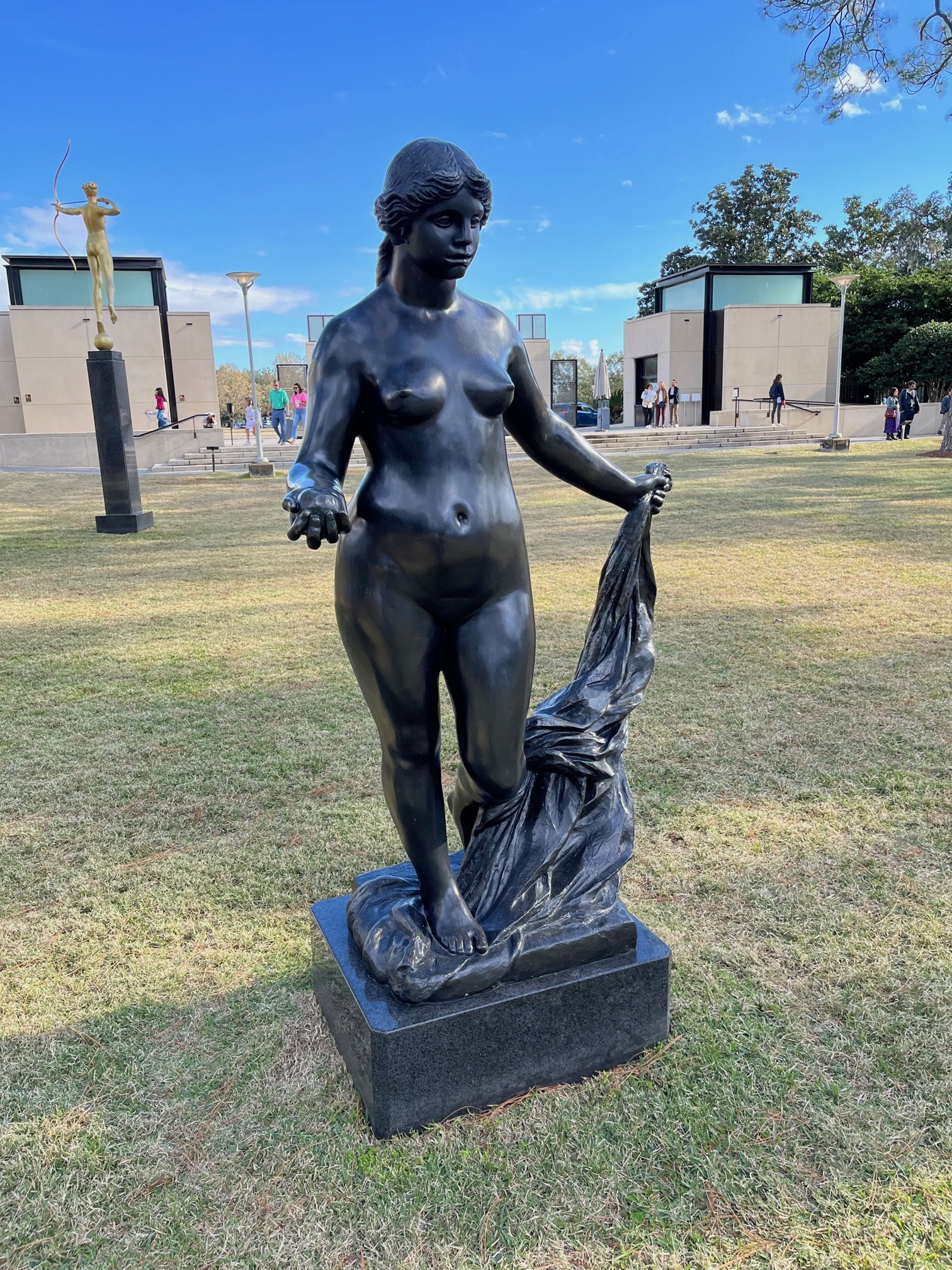

Statue of ____________________________

B. Describe three details of this statue that you think were intended to create meaning or incite emotion among the viewers:
1.
2.
3.
C. Research more about the environment of this statue, and explain what the creators of the sculpture garden in New Orleans were hoping to achieve.

D. In recent times, statues in the US have been at the center of violent riots (NY TIMES tells why). Many people demanded that certain statues be removed, which indeed happened on certain occasions (see example of September 8, 2021 discussed here CBS). This sparked protest among others who were against the removal. Explain the two sides of the debate, in particular the symbolism they associate with these statues?

- Side A:

- Side B:

F. The Governor of Virginia, Ralph Northam, made the statement, “The public monuments reflect the story we choose to tell about who we are as a people…It is time to display history as history, and use the public memorials to honor the full and inclusive truth of who we are today and in the future.” Apply this statement to sculpture garden in new Orleans and define the multiple roles of statues in modern American society.

II. INTRODUCING ANCIENT STATUES

A. As you watch the documentary Paul in Athens, list characteristics of ancient statues under the following categories:

1. Material/Color:

2. Location:

3. Size:

4. Associated features (symbols, objects):

B. The documentary mentions the “Sculptural Environment” of Graeco-Roman cities (see 05:50–06:25 and 15:19); Prof. Eliav edited a book by this title (see here). Browse the introduction to this book. In particular, explain the use of the term “environment”:

C. How do the elements in Section A above contribute to the “Sculptural Environment” of Roman cities?

D. Based on all the data you collected thus far, from this exercise and from the movie, define the role of statues in Roman cities and compare them to the American system you found in Section I.

III. DIVINE AND NON–DIVINE STATUES

Visual Language:

A. The ancient Graeco-Roman writer Lucian of Samosata says the following (in his book On the Syrian Goddess, chapter 32):

“The image [=statue] of Zeus looks entirely like Zeus in features and clothes and seated posture: you could not identify it otherwise even if you wished.”

On the most basic level, how would people in ancient times know the difference between human statues and divine statues?

B. Do you notice anything ironic or paradoxical about conventional ways of representing the gods?

C. The ancient statue below portray the goddess Aphrodite. Click on each image to examine it more closely:

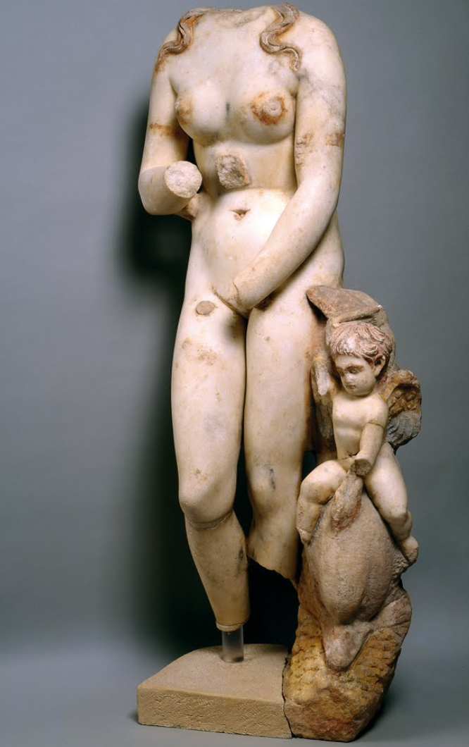
Aphrodite from Beth Shean, Israel (2nd century CE); Photo © The Israel Museum, Jerusalem, by Ardon Bar-Hama.
D. Compare this statue of Aphrodite with the above statue from New Orleans by creating a list of artistic/stylistic features that are human-like, and another list that give the statue a divine-like appearance.

 | Divine Features | Human Features
New Orleans Statue

Aphrodite of Beth Shean

E. based on this comparison – are the two statues of the same nature (or in other words did people in New Orleans and Beth Shean view the two statues in the same way?

Social Context:

A. The ancient travel writer Pausanias mentions a procession involving the cult-statues of the god Dionysus at Sicyon, a city in southern Greece (Descriptions of Greece, 2.7.5):

The god [Dionysus] is of gold and ivory, and by his side are Bacchanals of white marble [female followers of Dionysus]. These women they say are sacred to Dionysus and maddened by his inspiration. The Sicyonians have also some images which are kept secret. These, one night in each year, they carry to the temple of Dionysus from what they call the Cosmeterium, and they do so with lighted torches and native hymns.

What are three characteristics of this communal ritual?

1.
2.
3.

B. Recall your last visit to the BIG HOUSE—the Michigan Wolverine football stadium. What happened repeatedly there (or at other sports venues)? Give two examples, then compare and contrast them with the communal rituals related to statues of Dionysus:

1.

2.

C. Based on all this information and insight, explain the similarities and differences between the New Orleans Statue and the Beth Shean Statue:

IV. JEWISH VIEWS OF STATUES

A. The first-century CE Jewish writer Josephus expresses his opinion about King Herod’s habit to donate statues to non-Jewish cities during Roman times. In the passage below, locate and circle three references to proper behavior of Jews regarding statues according to Josephus:

[B]ecause of his [=Herod’s] ambition . . . and the flattering attention which he gave to Caesar and the most influential Romans, he was forced to depart from the customs (of the Jews) and to alter many of their regulations, for in his ambitious spending he founded cities and erected temples – not in Jewish territory, for the Jews would not have put up with this, since we are forbidden such things, including honoring of statues and sculptured forms in the manner of the Greeks – but these he built in foreign and surrounding territory. To the Jews he made the excuse that he was doing these things not on his own account but by command and order, while he sought to please Caesar and the Romans by saying that he was less intent upon observing the customs of his own nation than upon honoring them.

B. In your own words – how would a Jew in the days of Josephus view the Aphrodite of Beth Shean that you examined above? Explain the reasoning behind this position

V. JEWISH ANCESTRAL LAW

A. The Ten Commandments from the Bible (Exodus 20:1–5) were believed by ancient Jews to be sacred laws given to them by God (through Moses). The first two are listed below, numbered for the sake of analysis:

Then God spoke all these words:
- I am YHWH your God, who brought you out of the land of Egypt, out of the house of slavery; you shall have no other gods before me.
- a. You shall not make for yourself an idol, whether in the form of anything that is in heaven above, or that is on the earth beneath, or that is in the water under the earth.
b. You shall not bow down to them or worship them.

B. Think about the logical relationship between 2a and 2b (known together as The Second Commandment); there are two ways to explain how these two sentences relate to each other. What are they?

Option 1:

Option 2:

C. How did the Jews described by Josephus understand the Second Commandment (or in other words – which of the above two options did they hold?)

D. Go back to the documentary and explain how Paul understood the Second Commandment; did he and the Jews in Josephus (keep in mind, they lived at the same time) share the same understanding of the biblical directive? Explain:

VI. THE RABBIS AND THEIRR VIEWS OF IDOLATRY

A. Read the following debate between three second century CE rabbis (As brought in the book called the Mishnah, tratae Idolatry, chapter 3), numbered below for the sake of analysis:

- ‘All statues (tselamim) are forbidden [as idolatrous] because they are worshipped once a year,’ such is the statement of R. Meir.
- But] the [other] scholars (ḥakhamim) say, ‘[a statue] is not forbidden except one that has a stick or a bird or a ball.’
- R. Simeon b. Gamaliel says, ‘[a statue] which carries anything in its hand [is forbidden].’

Apply what you learnt above about Visual Language and Social Context to explain the disagreement between R. Meir (line 1) and the ḥakhamim (line 2):

D. How do the positions of R. Meir (line 1) and the ḥakhamim (line 2) compare to that of Paul? Regarding the spectrum of ancient Jewish views of statues, were the rabbis closer to Paul or the Jews described by Josephus?

VII. SUMMARY: PAUL AND GRAECO-ROMAN STATUES

Statues dominated the urban environment of Graeco-Roman cities. Throughout history people have suffused statues with symbolic significance. Sculptors and viewers partake in a dynamic discourse on the values, aesthetics, beliefs, ideals, and longings of their society.

Eliav Studied and wrote about this cultural process (and produced the movie you watched to introduce his ideas). Read one or two of Eliav’s studies on the topic (both are brought in the Bibliography of this exercise) and then explain the multiple perceptions that evolved around statues from Josephus to Paul to the Rabbis up to the people of New Orleans.

FURTHER RESEARCH:

Avery-Peck, Alan J. “Idolatry in Judaism.” Encyclopedia of Judaism. Brill Online Reference Works.

Curtis, Edward M. “Idol, Idolatry.” Pages 376–81 in Anchor Bible Dictionary, vol. 3.

Eliav, Yaron Z. “The Roman Bath as a Jewish Institution: Another Look at the Encounter Between Judaism and the Graeco-Roman Culture.” Journal for the Study of Judaism 31 (2000): 426–54.

______. “Roman Statues, Rabbis, and Graeco-Roman Culture.” Pages 99–115 in Jewish Literatures and Cultures: Context and Intertext. Ed. Anita Norich and Yaron Z. Eliav. Providence RI: Brown University Press, 2008.

______. “Viewing the Sculptural Environment: Shaping the Second Commandment.” Pages in Talmud Jerushalmi and Graeco-Roman Culture III. Ed. Peter Shäfer. Tübingen: Mohr Siebeck, 2002.

Elsner, Jaś. “Image and Ritual: Reflections on the Religious Appreciation of Classical Art.” Classical Quarterly 46 (1996): 515–31.

Estienne, Sylvia. “Images.” Pages 379–87 in A Companion to the Archaeology of Religion in the Ancient World. Ed. Rubina Raja and Jörg Rüpke. West Sussex, UK: John Wiley & Sons, 2015.

Gordon, Richard L. “The Real and the Imaginary: Production and Religion in the Graeco-Roman World.” Art History 2 (1979): 5–34.

Hezser, Catherine. “Palestinian Rabbis’ Encounter with Graeco-Roman Paganism: Rabban Gamliel in the Bathouse of Aphrodite in Acco (M. A.Z. 3:4)” in Jewish/Non-Jewish Relations, Between Exclusion and Embrace.

Steiner, Deborah Tarn. “Inside and Out.” Pages 79–134 in Images in Mind: Statues in Archaic and Classical Greek Literature and Thought. Princeton: Princeton University Press, 2001.

Yadin, Azzan. “Rabban Gamliel, Aphrodite’s Bath, and the Question of Pagan Monotheism.” Jewish Quarterly Review 96 (2006): 149–79.

