Name:___________________

PAUL IN ATHENS

UNDERSTANDING IDOLATRY: GRAECO-ROMAN STATUES AND THE JEWS

I. STATUES AND SYMBOLIC MEANING

A. Do you recognize this modern statue from Virginia? Click on the image to find clues about its identity.

Statue of ____________________________

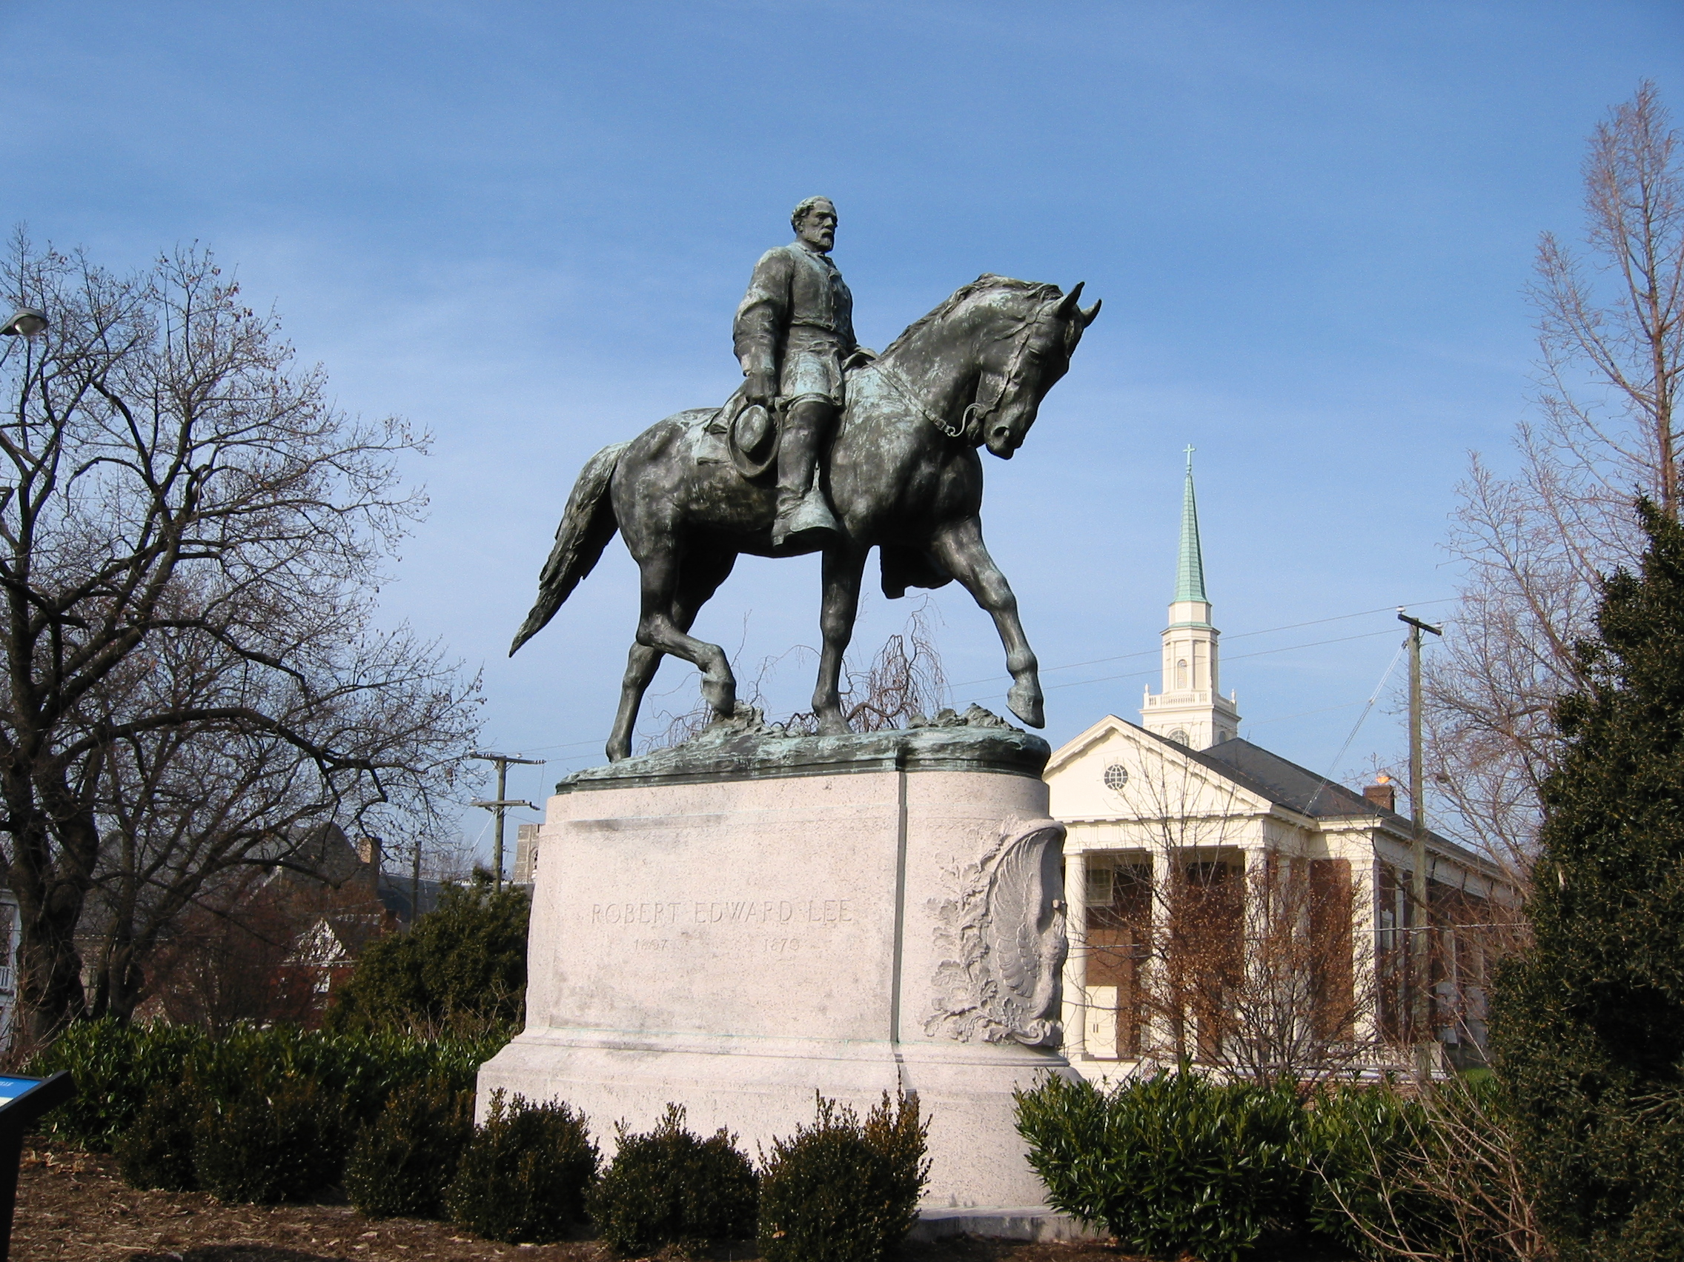

B. Describe four details of this statue that you think were devised to create meaning or incite emotion among the viewers:

1.
2.
3.
4.

C. Find the date on the statue base. What major war took place on US soil during this time?

D. The statue of General Lee was dedicated in 1924, almost 60 years after the Civil War. Browse this CNN news article; how is the statue connected to its founding figure and to the people who created it?

E. In recent times, this statue has been at the center of violent riots (NY TIMES tells why). Many people demand the statue’s removal, while others protest that such actions would erase southern heritage. What two ways does this statue function as a symbol?

1.

2.

F. Based on this one example, how would you define the role of statues in modern American society?

II. INTRODUCING ANCIENT STATUES

A. As you watch the documentary Paul in Athens, list characteristics of ancient statues under the following categories:

1. Material/Color:

2. Location:

3. Size:

4. Associated features (symbols, objects):

5. Style (expressions, postures):
B. The documentary mentions the “Sculptural Environment” of Graeco-Roman cities (see 05:50–06:25 and 15:19); Prof. Eliav edited a book by this title (see here). Browse the introduction to this book. In particular, explain the use of the term “environment”:

C. How do the elements in Section A above contribute to the “Sculptural Environment” of Roman cities?

D. Based on all the data you collected thus far, from this exercise and from the movie, define the role of statues in Roman cities and compare them to the American system you found in Section I.

III. DIVINE AND NON–DIVINE STATUES

A. The ancient Roman orator and politician Cicero conveys a wide-spread assumption of how people perceived Graeco-Roman statues (On the Nature of Gods, 1.81):

“…from our childhood Jupiter, Juno, Minerva, Neptune, Vulcan, and Apollo have been known to us by the appearance with which painters and sculptors have chosen to represent them; and not with that appearance only, but the equipment they carry, the clothes that they wear, and their age.”

B. On the most basic level, how would people in ancient times know the difference between human statues and divine statues?

C. Do you notice anything ironic or paradoxical about conventional ways of representing the gods?

D. The statues below portray divinities. Select each image to examine it more closely:

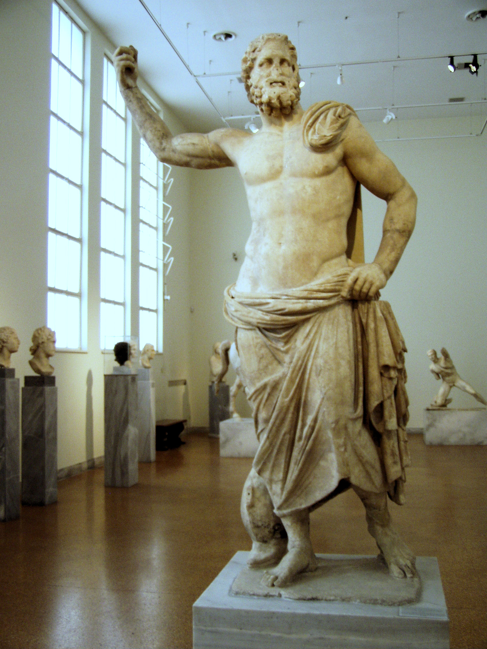  Poseidon of Melos (200 BCE), National Archaeology Museum, Athens | 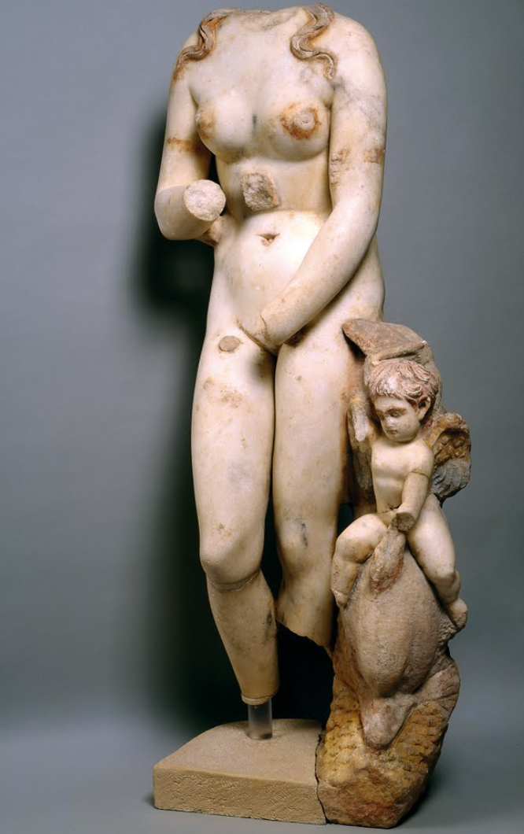  Aphrodite from Beth Shean, Israel (2nd century CE); Photo © The Israel Museum, Jerusalem, by Ardon Bar-Hama.
E. Create a list of artistic/stylistic features that are human-like, and another list that give the statue a divine-like appearance.

 | Divine Features | Human Features
Poseidon

Aphrodite

F. The ancient travel writer Pausanius mentions a procession involving the cult-statues of the god Dionysus at Sicyon, a city in southern Greece (Descriptions of Greece, 2.7.5):

The god [Dionysus] is of gold and ivory, and by his side are Bacchanals of white marble [female followers of Dionysus]. These women they say are sacred to Dionysus and maddened by his inspiration. The Sicyonians have also some images which are kept secret. These one night in each year they carry to the temple of Dionysus from what they call the Cosmeterium, and they do so with lighted torches and native hymns.

G. What are three characteristics of this communal ritual?

1.
2.
3.
H. Dissect the word “Cosmeterium.” The suffix “ium” denotes a room or place where an activity is carried out. Can you guess what happened here based on the first part of this word?

I. Why do you think people adorned statues? What did people hope to achieve by improving the statues’ appearance?

J. How do rituals related to divine statues (i.e., adorning, carrying in procession, lighting torches, singing hymns) establish social bonds?

K. Recall your last visit to the BIG HOUSE—the Michigan Wolverine football stadium. What happened repeatedly there (or at other sports venues)? Give two examples, then compare and contrast them with the communal rituals related to statues of Dionysus:

1.

2.

IV. JEWISH VIEWS OF STATUES

A. The first-century CE Jewish writer Josephus recounts the extreme resistance of the Jews to an attempt by emperor Caligula (12–41 CE) to install a statue of himself in the Jewish temple in Jerusalem. In the passage below, locate and circle three references to “ancestral law(s)”:

[The Jews] massed with their wives and children, and made their appeal to Petronius, first for their ancestral laws and then for themselves. He reminded them in detail of the power of Rome…and the futility of their demand: all subject nations in city after city had erected statues of Caesar to stand alongside their other gods, and for the Jews alone to oppose this practice was tantamount to rebellion, compounded by insult… [T]he Jews advanced the dictates of their ancestral law and ancestral customs, which forbade the placing of any graven image even of God, let alone of a man, not only in the temple sanctuary but anywhere else at all in the country…the crowd shouted that they were prepared to suffer anything in defense of their law. Petronius called for quiet, and asked them, “Will you go to war with Caesar?” The Jews replied that they offered twice-daily sacrifices for Caesar and the Roman people, but if Caesar insisted on the erection of these statues he must first sacrifice the entire Jewish nation.
B. What are four aspects (or “dictates”) of the ancestral law of the Jews regarding statues?
1.
2.
3.
4.

V. JEWISH ANCESTRAL LAW

A. The Ten Commandments from the Bible (Exodus 20:1–5) were believed by ancient Jews to be sacred laws given from God to Moses. The first two are listed below, numbered for the sake of analysis:

Then God spoke all these words:
- I am YHWH your God, who brought you out of the land of Egypt, out of the house of slavery; you shall have no other gods before me.
- a. You shall not make for yourself an idol, whether in the form of anything that is in heaven above, or that is on the earth beneath, or that is in the water under the earth.
b. You shall not bow down to them or worship them.

B. Think about the relationship between 2a and 2b; there are two ways to explain this relationship. What are they?

Option 1:

Option 2:

C. How did the Jews described by Josephus understand the Second Commandment?

D. Go back to the documentary and explain how Paul understood the Second Commandment; did he and the Jews in Josephus (keep in mind, they lived at the same time) share the same understanding of the biblical directive? Explain:

VI. THE RABBIS AND VIEWS OF IDOLATRY

A. Read the following anecdote of a second century CE rabbi (named Gamliel) encountering a Roman statue (of the goddess Aphrodite/Venus) in the public bathhouse (Mishna, Avodah Zarah, 3:4), numbered below for the sake of analysis:

- Proklos son of Plosfos (a gentile) asked Rabban Gamliel (a Jew) [a question] in Akko, while he was bathing in the bathhouse of Aphrodite.
- He said to him: “It is written in your Torah (Deut 13:17) ‘And let none of the condemned [pagan things, unlawful for Jews to possess] cling to your hand’; why then are you bathing in the bathhouse of Aphrodite? [Gamliel] said to him: one does not respond [to questions about the Torah] in the bathhouse.
- When he left, [Gamliel] said to [Proklos]: “I did not come into her territory; she came into my territory. They [the builders of the bathhouse] did not say: ‘Let us make a beautiful bathhouse for Aphrodite.’ Rather, they said: ‘Let us make Aphrodite for the beauty of the bathhouse.’
- Another reason: [even] if they gave you a lot of money, you would not enter before your idolatry [literally avodah zara, i.e., Proklos’ worship of Aphrodite] naked and defiled and urinating in front of it. Yet she stands on the sewer pipe and the entire nation urinates in front of her.
- The verse (Deut 12:3) only applies to ‘their gods’; that which he treats like a god is prohibited, and that which he does not treat like a god is permitted.”

B. Gamliel justifies his use of Aphrodite’s bathhouse on two principles. In your own words, summarize his first point (line 3).

C. What is Gamliel’s second point, beginning with his reference to money and Proklos’ worship of idols/statues (line 4)?

D. How does Gamliel’s position compare to that of Paul? Regarding the spectrum of ancient Jewish views of statues, were the rabbis closer to Paul or the Jews described by Josephus?

VII. SUMMARY: PAUL AND GRAECO-ROMAN STATUES

Statues dominated the urban environment of Graeco-Roman cities. Paul’s impression of Athens as an idol-forest is confirmed by Pausanias, who describes Athens as exceptional in its devotion to “religion” (Descriptions of Greece, 1.17.1):

In the Athenian market-place among the objects not generally known is an altar to Mercy, of all divinities the most useful in the life of mortals and in the vicissitudes of fortune, but honored by the Athenians alone among the Greeks. And they are conspicuous not only for their humanity but also for their devotion to religion. They have an altar to Shame-fastness, one to Rumor and one to Effort. It is quite obvious that those who excel in piety are correspondingly rewarded by good fortune.

Throughout history people have suffused statues with symbolic significance. Sculptors and viewers partake in a dynamic discourse on the values, aesthetics, beliefs, ideals, and longings of their society. Drawing on this exercise and the documentary Paul in Athens, why were Jews vehemently opposed to statues? From the time of Paul onwards, how would you characterize the evolution of Jewish attitudes towards Graeco-Roman statues/images/idols?

FURTHER RESEARCH:

Avery-Peck, Alan J. “Idolatry in Judaism.” Encyclopedia of Judaism. Brill Online Reference Works.

Curtis, Edward M. “Idol, Idolatry.” Pages 376–81 in Anchor Bible Dictionary, vol. 3.

Eliav, Yaron Z. “The Roman Bath as a Jewish Institution: Another Look at the Encounter Between Judaism and the Graeco-Roman Culture.” Journal for the Study of Judaism 31 (2000): 426–54.

______. “Roman Statues, Rabbis, and Graeco-Roman Culture.” Pages 99–115 in Jewish Literatures and Cultures: Context and Intertext. Ed. Anita Norich and Yaron Z. Eliav. Providence RI: Brown University Press, 2008.

______. “Viewing the Sculptural Environment: Shaping the Second Commandment.” Pages in Talmud Jerushalmi and Graeco-Roman Culture III. Ed. Peter Shäfer. Tübingen: Mohr Siebeck, 2002.

Elsner, Jaś. “Image and Ritual: Reflections on the Religious Appreciation of Classical Art.” Classical Quarterly 46 (1996): 515–31.

Estienne, Sylvia. “Images.” Pages 379–87 in A Companion to the Archaeology of Religion in the Ancient World. Ed. Rubina Raja and Jörg Rüpke. West Sussex, UK: John Wiley & Sons, 2015.

Gordon, Richard L. “The Real and the Imaginary: Production and Religion in the Graeco-Roman World.” Art History 2 (1979): 5–34.

Hezser, Catherine. “Palestinian Rabbis’ Encounter with Graeco-Roman Paganism: Rabban Gamliel in the Bathouse of Aphrodite in Acco (M. A.Z. 3:4)” in Jewish/Non-Jewish Relations, Between Exclusion and Embrace.

Steiner, Deborah Tarn. “Inside and Out.” Pages 79–134 in Images in Mind: Statues in Archaic and Classical Greek Literature and Thought. Princeton: Princeton University Press, 2001.

Yadin, Azzan. “Rabban Gamliel, Aphrodite’s Bath, and the Question of Pagan Monotheism.” Jewish Quarterly Review 96 (2006): 149–79.

