The Greek Gods

In the film, you have seen that Paul visited Athens and gave a speech in the city center. That speech was about religion, a subject that we will explore in this worksheet.

- What is religion? Use up to 50 words.

- The Oxford English Dictionary defines religion as ‘the belief in and worship of a superhuman controlling power, especially a personal God or gods.’ Is there more to religion than that?

- How, if at all, does religion influence your own life?

- Describe a religious experience you had or a religious event you participated in. What was religious about it? How important were (a) feelings, (b) ideas, and (c) words in this experience or event?

- In the second century AD, Lucian visited the temple of Hierapolis in Syria. In his book, On the Syrian Goddess, he gave a detailed description of what went on inside and around the temple. Read the excerpts from that book below. How is this temple different from a modern mosque, synagogue, or church? Note at least three points of difference.

In it are costly works and ancient dedications and many marvels and images worthy of divinity. The gods are especially manifest to them. Among them the statues sweat, and move, and deliver oracles, and there are often cries in the sanctuary when the temple has been locked up, which many have heard. … It is within these propylaea that the phalli stand which Dionysus erected, themselves three hundred fathoms tall. One of these phalli is climbed twice a year by a man who lives on top of the phallus for a span of seven days. … In the courtyard here are great cattle, horses, eagles, bears, and lions which graze at large; they do no harm to humans, and all are sacred and tame. They appoint many priests, of whom some slaughter the sacrificial victims, others pour libations; yet others are called fire-bearers or altar-attendants. In my time there, more than three hundred came to the sacrifice. All wear white, and have felt caps on their heads. … Sacrifice is performed twice daily, and they all attend. To Zeus they sacrifice in silence, with neither song nor aulos. But when they make offerings to Hera they sing and play the autos and rattle the castanets. (Lucian, On the Syrian Goddess 10, 28, 41-42)

- Now we turn to Athens in Classical Antiquity. The largest temple in Greece was the Temple of Zeus, which—once it was finally finished in the second century AD—covered an area of 50901 ft² and boasted 104 marble columns. The only people who went inside, however, were priests. What was the function of this temple?

- Below are pictures of three painted vases. Describe what you see. What is religious about the painted scenes?

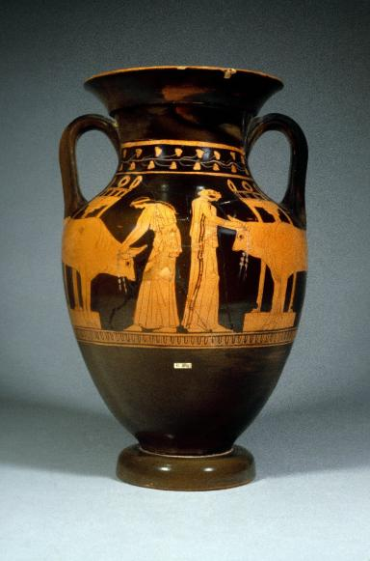
© The Trustees of the British Museum

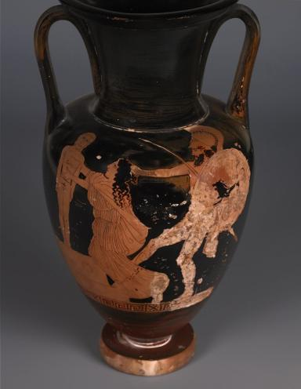
© The Trustees of the British Museum

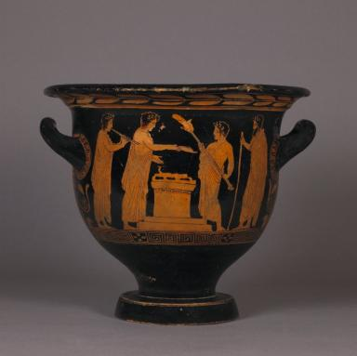
© The Trustees of the British Museum

- Below is a picture of a small marble statue of Cybele, the mother goddess, whose temple stood at the agora of Athens. Hundreds of Roman-era statuettes have been discovered. What was the function of such a small statue?

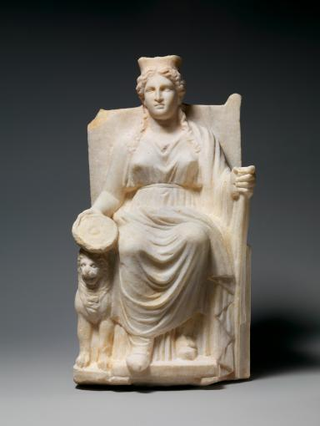
© Metropolitan Museum of Art

- On his visit to Athens, Paul gave a speech, a version of which can be found in the Bible. Read the opening of the speech below. What was Paul’s main argument?

People of Athens! I see that in every way you are very religious. For as I walked around and looked carefully at your objects of worship, I even found an altar with this inscription: to an unknown god. So you are ignorant of the very thing you worship—and this is what I am going to proclaim to you. The God who made the world and everything in it is the Lord of heaven and earth and does not live in temples built by human hands. And he is not served by human hands, as if he needed anything. Rather, he himself gives everyone life and breath and everything else. (Acts 17:22-25)

- Having watched the film and having seen the 360-degree photos, describe three 'objects of worship' that Paul might have seen in Athens.

- Paul says that the Athenians are ‘very religious’, but the Greek word he uses is deisidaimon, which could also mean ‘superstitious’. How, if at all, was Paul’s idea of religion different from that of the Athenians?

Further Reading

Bremmer, Jan N., Greek Religion (Oxford 1994), 1-10, 27-54. Chapter 2 is about the gods of the Greeks, and chapters 3 and 4 are about the practical aspects of Greek religion, sanctuaries and rituals.

Burkert, Walter, Greek Religion (Cambridge, Mass. 1985), 54-118. Burkert, using insights from anthropology, gives an innovate reconstruction and interpretation of Greek rituals.

Freeman, Charles, The Greek Achievement: The Foundation of the Western World (London, 1999), 127-148. Freeman devotes his short chapter on ‘spiritual experience’ mostly to the literary sources through which most of Greek religion has been preserved.

Price, Simon, Religions of the Ancient Greeks (Cambridge 1999), 11-66. The first chapter evaluates the ‘theology’ of the Greeks, the second explores the places where Greeks interacted with their Gods, the third investigates whether Greek polytheism was tolerant or not.

Translated by J.L. Lightfoot, Lucian: On the Syrian Goddess (Oxford: Oxford University Press, 2003).

