Paul in Athens: City of Ancient Rock

*materials needed: highlighter, pen or pencil

I. Athens and Environs

A. Take a minute to study the following map:

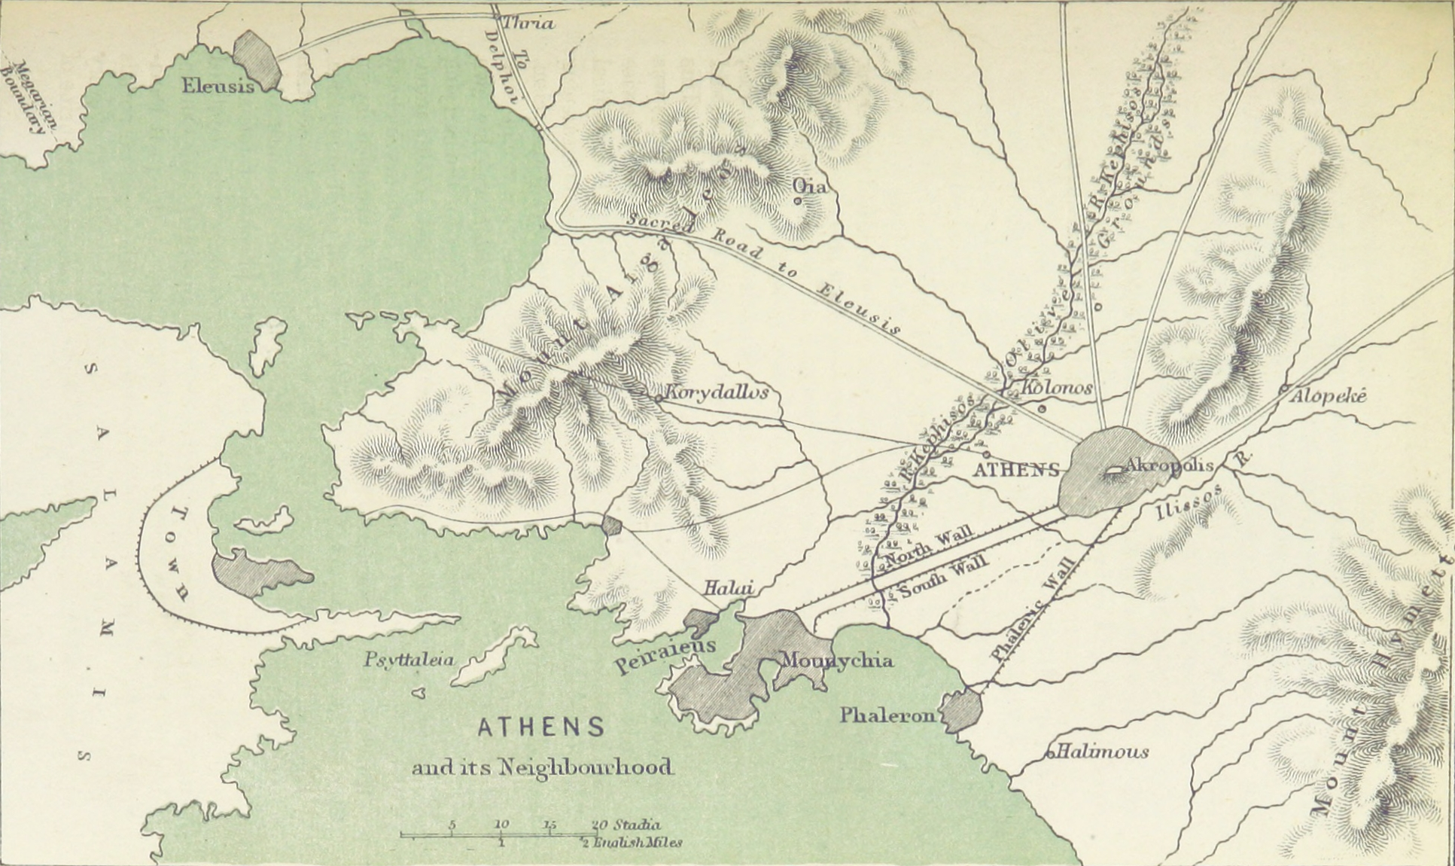
SARONIC GULF

N

*The area around Athens, southern Greece, is in light tan; the green shows part of the Saronic Gulf (connected to the Aegean Sea and the Mediterranean Sea); pencil-sketched contour lines depict mountains; five dark-shaded areas show population centers.

B. Locate the two largest dark-shaded regions on the map. Describe five aspects of their location and proximity to the nearby mountains, valleys, rivers, coasts, and other natural features. Make sure to mention specific names, and use this google map to assist your investigation.

1.

2.

3.

4.

5.
C. In the map above, all shaded regions are coastal, except one. The following map is a close-up of Athens and its port, Piraeus.

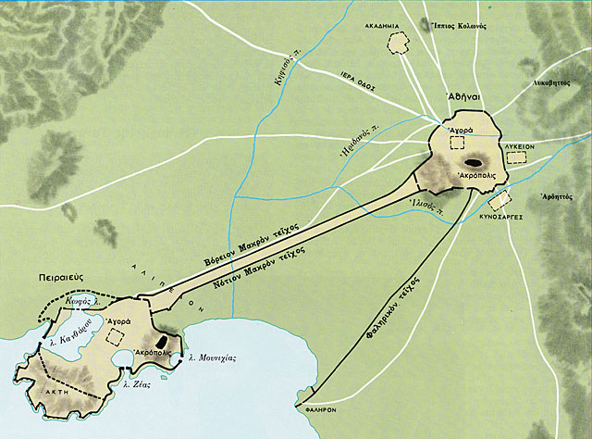

N

D. What may have attracted the early settlers to the inland location of Athens? Describe the two urban features in the diagram that Piraeus and Athens share:

E. Use the following key to transliterate the two Greek names into English:

A | B | Γ | Δ | Ε | Ζ | Η | Θ | Ι | Κ | Λ | Μ | Ν | Ξ | Ο | Π | Ρ | Σ | Τ | Υ | Φ | Χ | Ψ | Ω
α | β | γ | δ | ε | ζ | η | θ | ι | κ | λ | μ | ν | ξ | ο | π | ρ | σ, ς | τ | υ | φ | χ | ψ | ω
a | b | g | d | e | z | ē | th | i | c, k | l | m | n | xi | o | p | r | s | t | u | f | chi | psi | ō

1. Αγορά =

2. Ακρόπολις =
II. Acropolis

A. At the heart of ancient and modern Athens stands the Acropolis. The Greek word acropolis comes from two terms—akron (“high point, summit”) and polis (“city”). The image below shows the northwestern side of the Athenian Acropolis, with some of the ancient remains on top. The Aeropagus Hill is in the foreground.

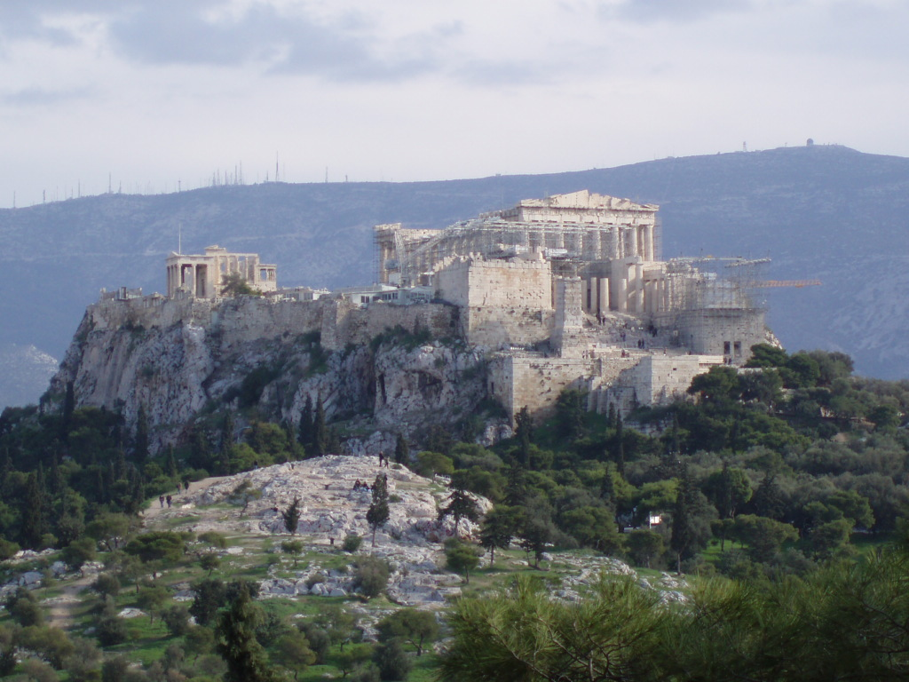

N

D

C

E

F

A

B

B. Use this 3D map to explore the site and identify the structures above. List them below:

C. Think strategically about ancient city planning. Could this rocky outcrop provide any advantages in a hostile environment? What in the picture can support or contradict your observations? As king of Athens, how would you use the Acropolis?

D. The Acropolis was unique because in addition to providing strategic defenses, it also featured protected access to an important natural resource: ________________. Can you identify what is pictured below? The diagram shows a cross section of a geological formation, located on the northeast side of the Acropolis. Draw lines to features that you can identify. Describe them in the margin.

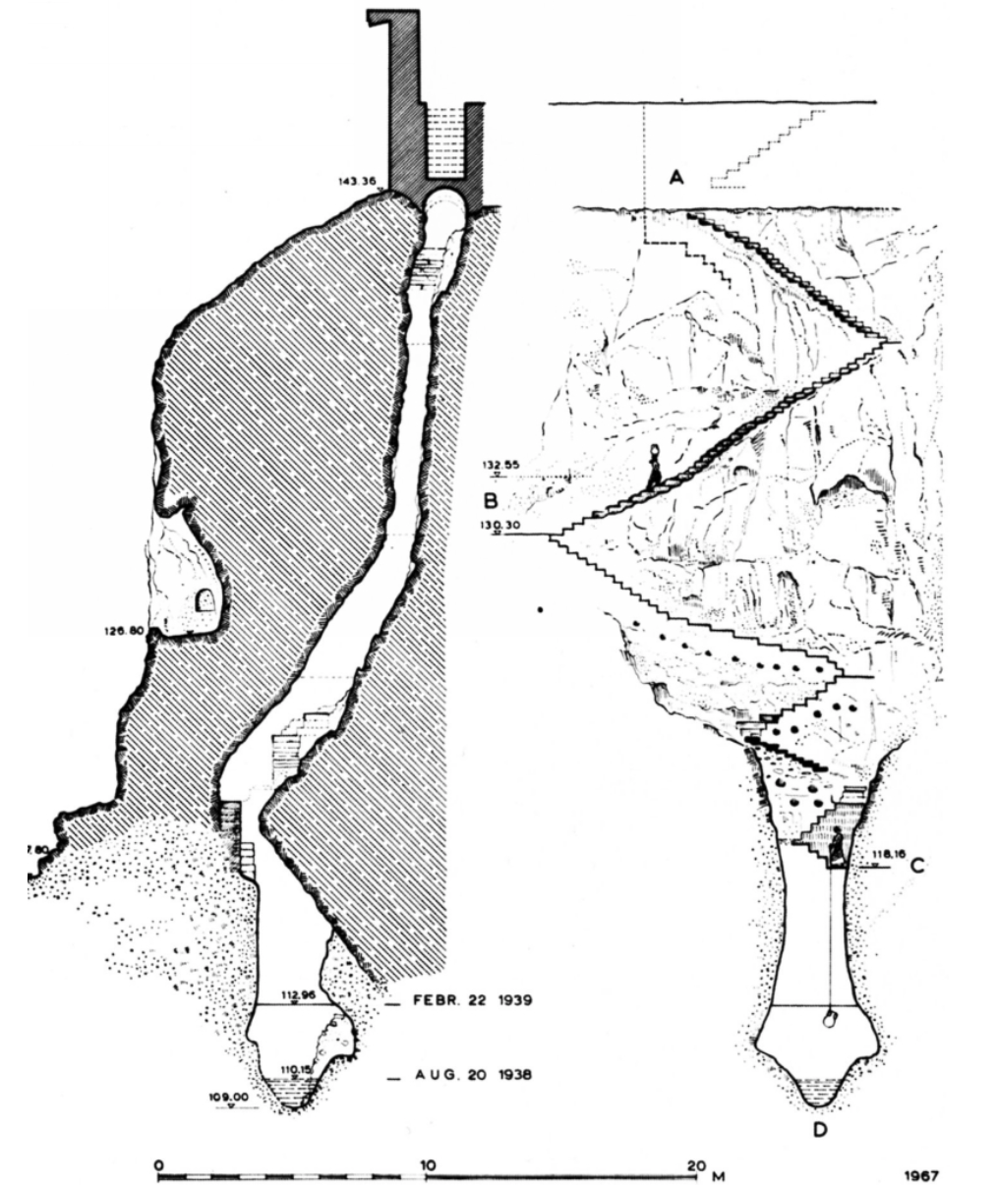

(Kienast, 1981)

III. The Cultural Texture of the Parthenon

A. The mythology, culture, and patron deities of Athens were linked, early on, to the prestige of the Acropolis itself. Examine the diagram below.

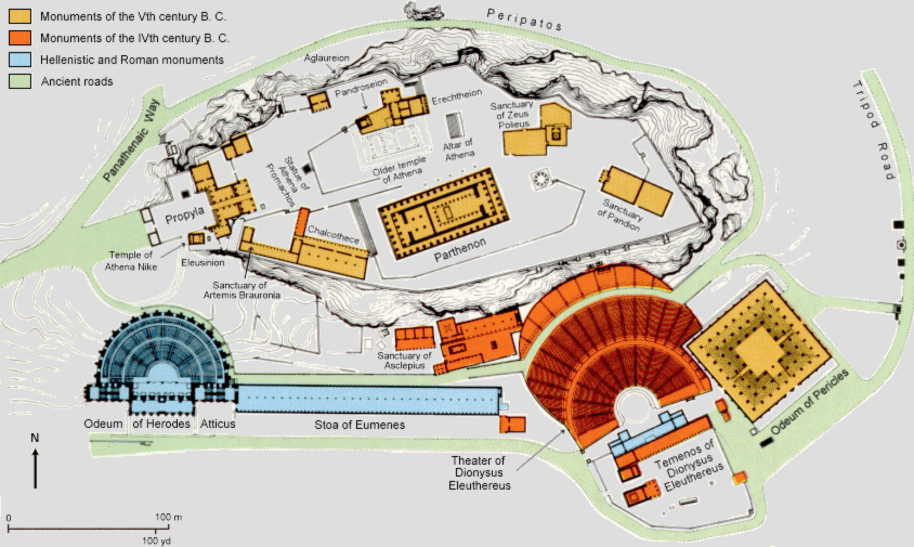

B. The names of temples and monuments on the Acropolis are original in Greek, which makes them sound obscure in English. Below are simple parts of Greek speech (nouns, prepositions, and proper names). Look over these terms, then proceed to the next step.

pan– [noun] “whole, all, universe” | peri– [preposition] “surrounding, around”
pro– [preposition] “before” | patos– [noun] “walkway, path”
pyla– [noun] “gate, entrance” | parthenos [noun] “maiden, young woman, virgin”
machos– [noun] “war, battle” | Pandrosus– daughter of Cecrops (king of Athens)
polis– [noun] “city” | Erechtheus– legendary king of Athens
ode– [noun] “a lyric poem to be sung” | Athena– virgin goddess of Athens, wisdom, military
temenos– [noun] “sacred ground” | Dionysus– god of theater, wine, and revelry
elethereus– [noun] “free, freedom” | Zeus– king/father of the gods, rules Mt. Olympus
C. In the space below, list the structures atop and around the Acropolis. Then use the Greek key to identify compound elements in each word. Lastly, guess the purpose of each structure.

D. Now classify these structures into religious and civic (i.e., urban) categories:

Religious | Civic

E. Given the layout of buildings and monuments, what can you observe about the relationship between religion and the state in the ancient world?

F. The festival processions on the Acropolis were lavish carnivals, celebrating military and intellectual superiority of Athens. Imagine you are Paul visiting the Acropolis. Where would you enter? What is the first thing you would see?

IV. Ancient Athens

A. Below is a map of ancient Athens with the old city streets and walls.

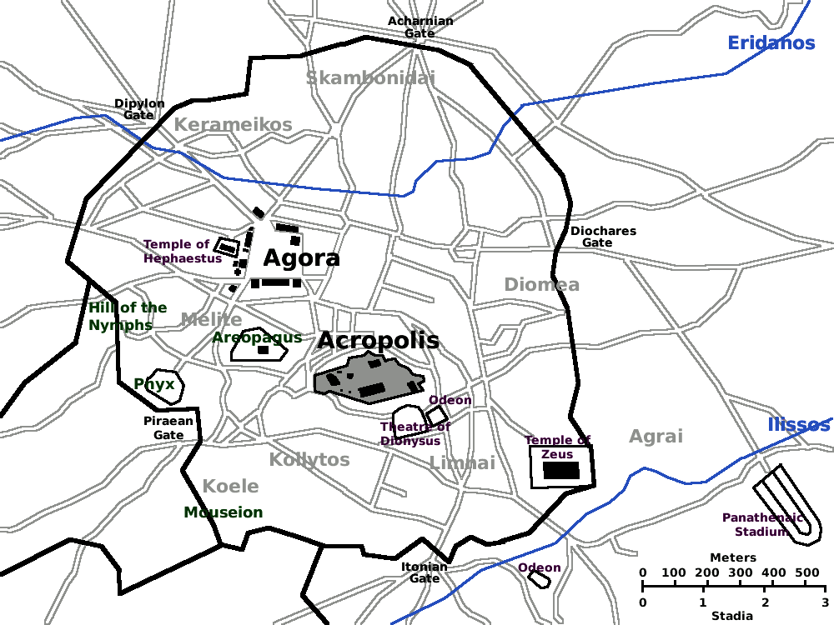
Hill

N

B. The names for the neighborhoods of ancient Athens appear in light gray. These are called demes (sg. deme, pronounced deem), similar to modern townships. List the demes below.

1.
2.
3.
4.
5.
6.
7.
C. Given the following report of Paul’s activities in Acts 17, what demes did Paul most likely frequent?

Acts 17:16 While Paul was waiting for them in Athens, he was deeply distressed to see that the city was full of idols. ¹⁷ So he argued in the synagogue with the Jews and the devout persons, and also in the marketplace (agora) every day with those who happened to be there. ¹⁸ Also some Epicurean and Stoic philosophers debated with him. Some said, “What does this babbler want to say?” Others said, “He seems to be a proclaimer of foreign divinities.” (This was because he was telling the good news about Jesus and the resurrection.) ¹⁹ So they took him and brought him to the Areopagus and asked him… Acts 18:1 After this Paul left Athens and went to Corinth.

D. What institutions/places are west of the Acropolis (written in green)? Write them below.

1.
2.
3.
4.

E. Using online resources (e.g., Wikipedia), briefly research each item. What role did these have in Athenian culture and politics?

F. How many gates provide entrance to Athens? (hint: follow the wall around the city) List them below:

G. According to the documentary, what was the most likely gate through which Paul entered the city (04:38)? Based on your investigations, do you agree or disagree? For the relationship between the coast and Athens, see maps above.

H. With reference to the map above, what two rivers flow through Athens?

I. See the maps on pp. 1–2 of this exercise. Can you determine the direction that these rivers flow? What clues might help you determine this?

J. Where is the confluence (or meeting point) of these two rivers?

K. Into what larger river do they flow?

V. Athens Today

A. Modern Athens has long outgrown its old city walls. The population now sprawls across the Athenian plain. Natural features, however, continue to play a role in urban development. Describe the image below. Draw lines to 5 modern features and identify them in the margins.

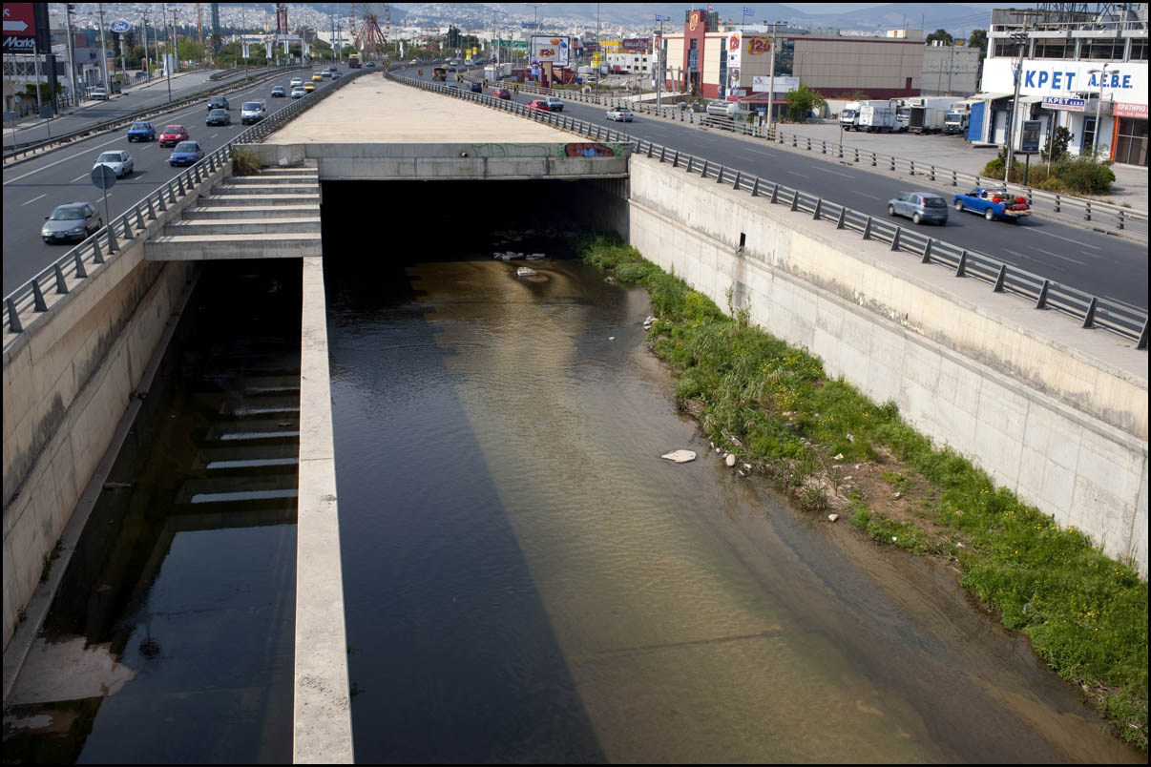

N

B. This link to Google maps takes you to the highway pictured above: E75, the busiest highway in modern Greece. Zoom in and out for orientation. Then follow the contours of the highway; begin at the coast between Piraeus and Faliro. Take the highway north, until you arrive at the base of the Penteli and Parnitha mountains. By comparing the route of E75 with the maps above, can you identify the river in the image?

C. Based on your investigations, briefly describe the developments that led to the construction of the highway in this location.

VI. Summary

The history of a region is often directly shaped by its geological and topographic features. Drawing on your knowledge from the “Paul in Athens” film and the exercises above, how have the natural features of Athens and its environs shaped human development in this region?
Further Research:

McGregor, James. Athens. Cambridge: Harvard University Press, 2014.

Higgins, Michael D., and Reynold Higgins. “Attica.” In A Geological Companion to Greece and the Aegean. Ithaca: Cornell University Press, 1996.

McDonald, William A. “Archaeology and St. Paul’s Journeys in Greek Lands: Athens.” Biblical Archaeologist 4.1 (1941): 1–10.

Columbia University; Interactive View of Parthenon Frieze: http://www.mcah.columbia.edu/parthenon/flash/main.htm

Ancient Athens 3D Reconstructions: https://web.archive.org/web/20110419202910/http://ancientathens3d.com:80/romanathEn.htm

Beard, Mary. The Parthenon. Revised Edition. Cambridge: Harvard University Press, 2010.

Stuttard, David. Parthenon: Power and Politics on the Acropolis. British Museum Press, 2013.

