Name:________________________

The Mediterranean World: An Investigative Exercise

*Material needed for this exercise – colored pens/pencils (black, blue, and red)

I. Names and Places

a. As you watch the video, listen for the names that you think might refer to a country, region, or city. Record them in the table below:

Country/Region | Cities

b. Using a black pen or pencil, plot these locations on the map (found as the last page of this exercise; un-attach if easier to work with). Follow the link to the Mediterranean region. Use the search box in the upper left-hand corner of the website to locate the country or city. Using a blue pen, also mark the bodies of water (e.g., Aegean Sea, Mediterranean Sea, etc.) on the map and label them by name.

II. Geography of Paul’s Travels

a. Paul, a Jew from Tarsus, embarked on three major journeys to spread his beliefs about Jesus and to establish communities of believers around the Mediterranean. Paul’s travels are recorded in the book of Acts, part of the New Testament, which is an ancient collection sources about Jesus, Paul, and the early church communities. Key passages from Acts are presented below, translated from Greek into English. Click on the links to follow Paul in his journey from Jerusalem to Athens, and using a red pen/pencil plot these on the map above. Then draw a line with arrows connecting the dots. (Note: lower case = cities; UPPER CASE = PROVINCES).

[After leaving Jerusalem and Antioch] ^{15:41} [Paul] went through SYRIA and CILICIA, strengthening the churches. ^{16:1} Paul went on also to Derbe and to Lystra, where there was a disciple named Timothy, the son of a Jewish woman who was a believer; but his father was a Greek. ² He was well spoken of by the believers in Lystra and Iconium.

^{16:6} They went through the region of PHRYGIA and GALATIA, having been forbidden by the Holy Spirit to speak the word in Asia. ⁷ When they had come opposite MYSIA, they attempted to go into BITHYNIA, but the Spirit of Jesus did not allow them; ⁸ so, passing by Mysia, they went down to Troas. ⁹ During the night Paul had a vision: there stood a man of MACEDONIA pleading with him and saying, “Come over to Macedonia and help us.” ¹⁰ When he had seen the vision, we immediately tried to cross over to Macedonia, being convinced that God had called us to proclaim the good news to them. ¹¹ We set sail from Troas and took a straight course to Samothrace, the following day to Neapolis, ¹² and from there to Philippi, which is a leading city of the district of Macedonia and a Roman colony. We remained in this city for some days.

^{17:1} After Paul and Silas had passed through Amphipolis and Apollonia, they came to Thessalonica, where there was a synagogue of the Jews. ² And Paul went in, as was his custom, and on three Sabbath days argued with them from the scriptures, ³ explaining and proving that it was necessary for the Messiah to suffer and to rise from the dead, and saying, “This is the Messiah, Jesus whom I am proclaiming to you.”

^{17:14} Then the believers immediately sent Paul away to the coast, but Silas and Timothy remained behind. ¹⁵ Those who conducted Paul brought him as far as Athens; and after receiving instructions to have Silas and Timothy join him as soon as possible, they left him.

III. Geographic Significance

a. From your investigations so far, in what region of the ancient Mediterranean did Paul spend most of his time?

b. Where is Athens in relation to the Mediterranean world? Is it central or peripheral?

c. Think about a journey or trip you took in the past. Did you make an itinerary? What locations were important to you? Why?

d. From your knowledge of the video, what might have been important to Paul about Athens? Why did he include Athens in his itinerary?

IV. Logistics and Significance

a. Return to Google Maps to retrace Paul’s steps. In the search box menu (top left), select “Terrain.” What kinds of topographic features did Paul encounter along the way (e.g., mountains, seas, rivers)? List their names and describe them below.

b. Would this make Paul’s journey easy or arduous? Why or why not?

c. Given Paul’s route, what modes of travel did he use?

d. In the search box on the Google maps website here, type “Jerusalem to Athens.” This provides directions and time estimates based on modern modes of travel, but one option is walking. Select this option, then click and drag the route to Paul’s approximate path. Record the combined details for traveling by foot in the table below. One day of travel was typically 20 miles.

 | Distance | Average per day | Days travelling?
Foot |  | 20 miles

e. Bread consumption in the ancient world was relatively high. An average Roman adult male ate about 2 pounds of bread each day. Assuming this was true for Paul, how much money would he need at a minimum for bread on his journey from Jerusalem to Athens? Use the following formulas to calculate Paul’s total cost of food.

1 modius of wheat would last about 7 days
2 denarii could buy 1 modius
1 denarius = the pay for one day of labor
If you earned $10 /hour, then 8 hours/day = $____ = 1 denarius

How many modii (plural) of wheat did Paul eat on his three-month journey, and how much did this cost?

___ modii per month = __ _ modii for 3 months

2 days labor = $ _ = 1 modius x _ _ modii (total) = $_____
f. When Paul stayed in villages and towns, he was often the guest in Jewish households. Assuming that he paid for lodging at least half the time, and assuming that overnight lodging costed about $25 per night, how much money would Paul need?

___ nights x $25 per night = $ _ ___

g. What is the minimum cost of food and lodging for Paul’s trip, one-way? $________

h. Drawing on the above data, how would you describe the amount of effort and resources required to travel from Jerusalem to Athens?

V. Paul on the Road: Hospitality, Risk, Danger

a. Ovid was a famous Latin poet of the early Roman Empire (43 BCE–18 CE). He recounts a well-known myth in which the gods Jupiter and Mercury (earlier Greek version: Zeus and Hermes) travel to a town in Phrygia and seek lodging for the night. Taking on human form, they appear to an old woman Baucis, and her husband Philemon. The following is a small excerpt from the story:

“Jupiter went [to an old town], disguised as a mortal, and Mercury, the descendant of Atlas, setting aside his wings, went with his father, carrying the caduceus [i.e., messenger scepter]. A thousand houses they approached, looking for a place to rest: a thousand houses were locked and bolted. But one received them: it was humble it is true, roofed with reeds and stems from the marsh, but pious Baucis and the equally aged Philemon, had been wedded in that cottage in their younger years, and there had grown old together.” (Metamorphoses VIII, 611–678)

(1) The story was originally told to illustrate the power of the gods, but reading between the lines, describe the real-life situation behind this story and its causes?

(2) What challenges would this pose for travelers in antiquity?

b. The quote below is attributed to the philosopher and Christian theologian Augustine of Hippo (354–430 CE): “The world is book, and those who do not travel read only one page”
(paraphrase inspired by Letter 43)

(1) Why do you think a “book” was a fitting metaphor for Augustine?

(2) In what ways does a “book” compare to the “world”?

(3) Why does “one page” of a book represent those who do not travel?

c. Examine the advertisement below:

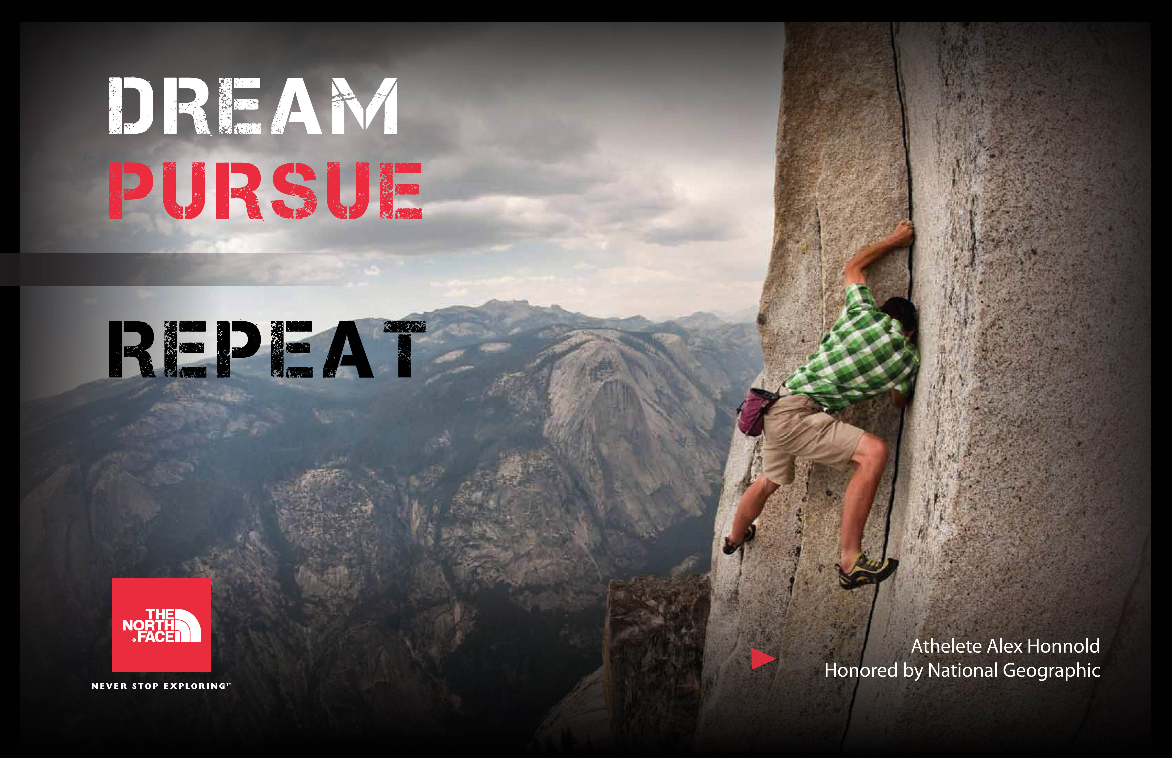

(1) Describe the feeling inspired by this North Face advertisement through its use of words and imagery.

Dream:

Pursue:

Repeat:

(2) What type of person might find this advertisement appealing?

d. What insights can we gain about Paul, or any traveler in the ancient Mediterranean, from the quote of Augustine and the North Face advertisement?

e. In your opinion, given the geographic challenges, financial burden, and risk to personal safety in travelling from Jerusalem to Athens, how would you describe Paul’s personality? What does this suggest about Paul’s understanding of his role in the world?

For further research:

Brodersen, Kai. “The Presentation of Geographical Knowledge for Travel and Transport in the Roman World: Itineraria non tantum adnotata sed etiam picta.” Pages 7–21 in Travel and Geography in the Roman Empire. Ed. Colin Adams and Ray Laurence. London/New York: Routledge, 2001.

Casson, Lionel. “On the Sea” and “On the Road.” Pages 149–62, 176–96 in Travel in the Ancient World. 2nd ed. Baltimore/London: John Hopkins University Press, 1994.

Rapske, Brian M. “Acts, Travel and Shipwreck.” Pages 1–47 in The Book of Acts in its First Century Setting. Volume 2: Graeco-Roman Setting. Ed. David W. J. Gill and Conrad Gempf. Grand Rapids: Eerdmans, 1994.

Rauh, Nicholas, Matthew Dillon, and T. Davina McClain. “Ochlos Nautikos: Leisure Culture and Underclass Discontent in the Roman Maritime World.” Pages 197–242 in The Maritime World of Ancient Rome. Ann Arbor: University of Michigan Press, 2008.

Schellenberg, Ryan. “Danger in the wilderness, danger at sea”: Paul and the Perils of Travel.” Pages 141–61 in Travel and Religion in Antiquity. Ed. Philip Harland; London, ON: Wilfred Laurier University Press, 2011.

